**IOT Assignment 1**

**Topic : Smart Home in Thinker CAD using 2+ sensors, Led and Buzzer in Single code.**

Name: Abitha Sree K

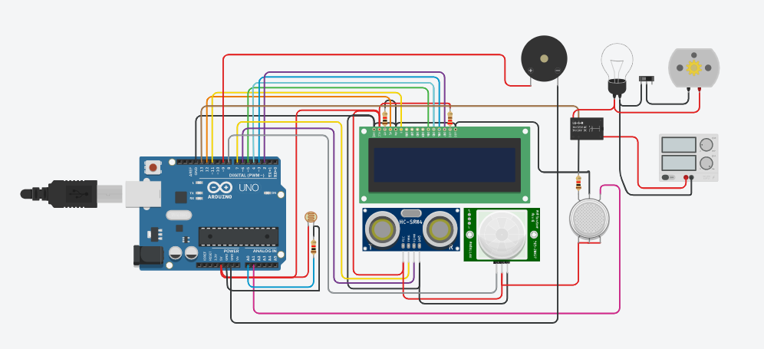

**Fig: Smart Home Simulation Design**

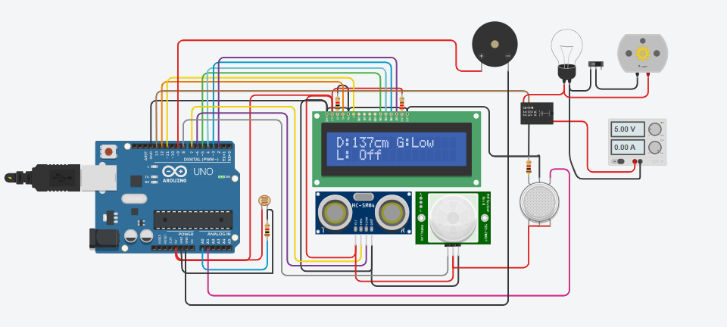

**Fig: Smart Home Simulation Design Output**

**Code:**

#include <LiquidCrystal.h>

LiquidCrystal lcd(12, 11, 5, 4, 3, 2);

int distanceThreshold = 0;

int cm = 0;

int inches = 0;

int buzzer=9;

int releNO = 13;

int inputPir = 8;

int val = 0;

int resuldoSensorLDR;

int sensorLDR = A0;

int const PINO_SGAS = A1;

long readUltrasonicDistance(int triggerPin, int echoPin)

{

pinMode(triggerPin, OUTPUT);

digitalWrite(triggerPin, LOW);

delayMicroseconds(2);

digitalWrite(triggerPin, HIGH);

delayMicroseconds(10);

digitalWrite(triggerPin, LOW);

pinMode(echoPin, INPUT);

return pulseIn(echoPin, HIGH);

}

void setup() {

lcd.begin(16, 2);

pinMode(releNO, OUTPUT);

pinMode(inputPir, INPUT);

pinMode(sensorLDR, INPUT);

Serial.begin(9600);

}

void loop() {

distanceThreshold = 350;

cm = 0.01723 * readUltrasonicDistance(7, 6);

inches = (cm / 2.54);

lcd.setCursor(0,0);

lcd.print("D:");

lcd.print(cm);

lcd.print("cm");

delay(10);

pinMode(buzzer, OUTPUT);

if(buzzer >= 15 && buzzer <= 30)

{

digitalWrite(buzzer, HIGH);

delay(2000);

}

else

{

digitalWrite(buzzer, LOW);

delay(2000);

}

val = digitalRead(inputPir);

resuldoSensorLDR = analogRead(sensorLDR);

if(resuldoSensorLDR<600)

{

if(val == HIGH)

{

digitalWrite(releNO, HIGH);

lcd.setCursor(0,1);

lcd.print("L: On ");

delay(5000);

}

else{

digitalWrite(releNO, LOW);lcd.setCursor(0,1);

lcd.print("L: Off");

delay(300);

}

}

else{ digitalWrite (releNO, LOW);

Serial.println(resuldoSensorLDR);

delay(500);

}

int color = analogRead(PINO_SGAS);

lcd.setCursor(8,0);

//lcd.print("");

if(color <= 85){

lcd.print("G:Low ");

} else if(color <= 120){

lcd.print("G:Med ");

} else if(color <= 200){

lcd.print("G:High");

} else if(color <= 300){

lcd.print("G:Ext ");

}

delay(250);

}